Національний технічний університет України

«Київський політехнічний інститут імені Ігоря Сікорського»

Факультет інформатики та обчислювальної техніки

Кафедра обчислювальної техніки

Основи паралельного програмування

Лабораторна робота №5

**«Потоки в бібліотеці OpenMP»**

Виконала:

студентка групи ІО-64

Бровченко А. В.

Перевірив:

Корочкін О. В.

Київ

2018 р.

**Завдання:**

F1: C = A – B*(MA*MС)*е

F2: MF = MF*MG*k

F3: O = SORT(P)*(MR*MT)

**Лістинг програми:**

**Lab5.cpp**

#include <omp.h>

#include "F1.h"

#include "F2.h"

#include "F3.h"

const int N = 200;

int main() {

cout << "Lab 5 start" << endl << endl;

F1 f1 = F1(N);

F2 f2 = F2(N);

F3 f3 = F3(N);

int tid;

#pragma omp parallel num_threads(3)

{

tid = omp_get_thread_num();

switch (tid) {

case 0:

f1.run();

case 1:

f2.run();

case 2:

f3.run();

}

}

cout << endl << "Lab 5 end" << endl << endl;

cout << "Press Enter...";

string t;

getline(cin, t);

}

**F1.h**

#pragma once

#include <iostream>

#include <Windows.h>

#include "Matrix.h"

class F1 {

private:

Vector* result;

int N;

public:

F1(int N);

Vector* getResult();

static DWORD WINAPI startThread(void* param);

DWORD run();

};

**F1.cpp**

#include "F1.h"

F1::F1(int N) {

this->N = N;

}

Vector* F1::getResult() {

return result;

}

DWORD WINAPI F1::startThread(void* param) {

F1* This = (F1*) param;

return This->run();

}

DWORD F1::run() {

cout << "Task 1 start\n";

long *e = new long(3);

Vector *A = new Vector(N), *B = new Vector(N);

Matrix *MA = new Matrix(N), *MC = new Matrix(N);

result = A->sub((MA->multiply(MC))->multiply(B)->multiply(e));

cout << "Task 1 end\n";

delete A;

delete B;

delete e;

delete MA;

delete MC;

return 0;

}

**F2.h**

#pragma once

#include <iostream>

#include <Windows.h>

#include "Matrix.h"

class F2 {

private:

Matrix* result;

int N;

public:

F2(int N);

Matrix* getResult();

static DWORD WINAPI startThread(void* param);

DWORD run();

};

**F2.cpp**

#include "F2.h"

F2::F2(int N) {

this->N = N;

}

Matrix* F2::getResult() {

return result;

}

DWORD WINAPI F2::startThread(void* param) {

F2* This = (F2*) param;

return This->run();

}

DWORD F2::run() {

cout << "Task 2 start\n";

long *k = new long(7);

Matrix *MF = new Matrix(N), *MG = new Matrix(N);

result = MF->multiply(MG)->multiply(k);

cout << "Task 2 end\n";

delete MF;

delete MG;

delete k;

return 0;

}

**F3.h**

#pragma once

#include <iostream>

#include <Windows.h>

#include "Matrix.h"

class F3 {

private:

Vector* result;

int N;

public:

F3(int N);

Vector* getResult();

static DWORD WINAPI startThread(void* param);

DWORD run();

};

**F3.cpp**

#include "F3.h"

F3::F3(int N) {

this->N = N;

}

Vector* F3::getResult() {

return result;

}

DWORD WINAPI F3::startThread(void* param) {

F3* This = (F3*)param;

return This->run();

}

DWORD F3::run() {

cout << "Task 3 start\n";

Vector *P = new Vector(N);

Matrix *MT = new Matrix(N), *MR = new Matrix(N);

result = (MR->multiply(MT))->multiply(P->sort());

cout << "Task 3 end\n";

delete P;

delete MT;

delete MR;

return 0;

}

**Vector.h**

#pragma once

#include <random>

#include <ctime>

#include <string>

using namespace std;

class Vector {

private:

long* grid;

int N;

public:

Vector();

Vector(int N);

Vector(long* grid, int N);

~Vector();

int getSize();

long get(int i);

Vector* sum(Vector* v);

Vector* sub(Vector* v);

Vector* multiply(long* a);

Vector* multiply(Vector* v);

Vector* sort();

string toString();

};

**Vector.cpp**

#include "Vector.h"

#include <iostream>

Vector::Vector() {}

Vector::Vector(int N) {

this->N = N;

srand(time(NULL));

grid = new long[N];

for (int i = 0; i < N; ++i)

grid[i] = rand() % 20;

}

Vector::Vector(long* grid, int N) {

this->N = N;

this->grid = new long[N];

for (int i = 0; i < N; ++i)

this->grid[i] = grid[i];

}

Vector::~Vector() {

delete[] grid;

}

int Vector::getSize() {

return N;

}

long Vector::get(int i) {

return grid[i];

}

Vector* Vector::sum(Vector* v) {

int N = getSize();

long* newGrid = new long[N];

for (int i = 0; i < N; ++i)

newGrid[i] = grid[i] + v->get(i);

Vector* newVector = new Vector(newGrid, N);

delete[] newGrid;

return newVector;

}

Vector* Vector::sub(Vector* v) {

int N = getSize();

long* newGrid = new long[N];

for (int i = 0; i < N; ++i)

newGrid[i] = grid[i] - v->get(i);

Vector* newVector = new Vector(newGrid, N);

delete[] newGrid;

return newVector;

}

Vector* Vector::multiply(long* a) {

int N = getSize();

long* newGrid = new long[N];

for (int i = 0; i < N; ++i) {

newGrid[i] = *a * grid[i];

}

Vector* newVector = new Vector(newGrid, N);

delete[] newGrid;

return newVector;

}

Vector* Vector::multiply(Vector* v) {

int N = getSize();

long* newGrid = new long[N];

for (int i = 0; i < N; ++i) {

newGrid[i] = v->get(i) * grid[i];

}

Vector* newVector = new Vector(newGrid, N);

delete[] newGrid;

return newVector;

}

Vector* Vector::sort() {

int N = getSize();

long* newGrid = new long[N];

for (int i = 0; i < N; ++i)

newGrid[i] = grid[i];

for (int i = 0; i < N; ++i) {

for (int k = 0; k < N - i - 1; ++k) {

if (newGrid[k] > newGrid[k + 1]) {

long t = newGrid[k];

newGrid[k] = newGrid[k + 1];

newGrid[k + 1] = t;

}

}

}

Vector* newVector = new Vector(newGrid, N);

delete[] newGrid;

return newVector;

}

string Vector::toString() {

string res = "";

int N = getSize();

for (int i = 0; i < N; ++i)

res += grid[i] + " ";

return res;

}

**Matrix.h**

#pragma once

#include <random>

#include <ctime>

#include "Vector.h"

class Matrix {

private:

long** grid;

int N;

public:

Matrix(int N);

Matrix(long** grid, int N);

~Matrix();

long get(int i, int k);

int getSize();

Matrix* multiply(Matrix* m);

Vector* multiply(Vector* v);

Matrix* multiply(long* a);

Matrix* sum(Matrix* m);

long get_min();

long get_max();

string toString();

};#pragma once

#include <random>

#include <ctime>

#include "Vector.h"

class Matrix {

private:

long** grid;

int N;

public:

Matrix(int N);

Matrix(long** grid, int N);

~Matrix();

long get(int i, int k);

int getSize();

Matrix* multiply(Matrix* m);

Vector* multiply(Vector* v);

Matrix* multiply(long* a);

Matrix* sum(Matrix* m);

long get_min();

long get_max();

string toString();

};

**Matrix.cpp**

#include "Matrix.h"

#include <iostream>

Matrix::Matrix(int N) {

this->N = N;

srand(time(NULL));

grid = new long*[N];

for (int i = 0; i < N; ++i)

grid[i] = new long[N];

for (int i = 0; i < N; ++i)

for (int k = 0; k < N; ++k)

grid[i][k] = rand() % 20;

}

Matrix::Matrix(long** grid, int N) {

this->N = N;

this->grid = new long*[N];

for (int i = 0; i < N; ++i) {

this->grid[i] = new long[N];

for (int k = 0; k < N; ++k)

this->grid[i][k] = grid[i][k];

}

}

Matrix::~Matrix() {

int N = getSize();

for (int i = 0; i < N; ++i)

delete[] grid[i];

delete[] grid;

}

long Matrix::get(int i, int k) {

return grid[i][k];

}

int Matrix::getSize() {

return N;

}

Matrix* Matrix::multiply(Matrix* m) {

int N = getSize();

long** newGrid = new long*[N];

for (int i = 0; i < N; ++i)

newGrid[i] = new long[N];

for (int i = 0; i < N; ++i) {

for (int k = 0; k < N; ++k) {

newGrid[i][k] = 0;

for (int j = 0; j < N; ++j) {

newGrid[i][k] += grid[i][j] * m->get(j, k);

}

}

}

Matrix* newMatrix = new Matrix(newGrid, N);

for (int i = 0; i < N; ++i)

delete[] newGrid[i];

delete[] newGrid;

return newMatrix;

}

Vector* Matrix::multiply(Vector* v) {

int N = getSize();

long* newGrid = new long[N];

for (int i = 0; i < N; ++i) {

newGrid[i] = 0;

for (int k = 0; k < N; ++k) {

newGrid[i] += v->get(k) * grid[i][k];

}

}

Vector* newVector = new Vector(newGrid, N);

delete[] newGrid;

return newVector;

}

Matrix* Matrix::multiply(long *a) {

int N = getSize();

long** newGrid = new long*[N];

for (int i = 0; i < N; ++i)

newGrid[i] = new long[N];

for (int i = 0; i < N; ++i) {

for (int k = 0; k <N; ++k) {

newGrid[i][k] = grid[i][k] * *a;

}

}

Matrix* newMatrix = new Matrix(newGrid, N);

for (int i = 0; i < N; ++i)

delete[] newGrid[i];

delete[] newGrid;

return newMatrix;

}

Matrix* Matrix::sum(Matrix* m) {

int N = getSize();

long** newGrid = new long*[N];

for (int i = 0; i < N; ++i)

newGrid[i] = new long[N];

for (int i = 0; i < N; ++i) {

for (int k = 0; k < N; ++k) {

newGrid[i][k] = grid[i][k] + m->get(i, k);

}

}

Matrix* newMatrix = new Matrix(newGrid, N);

for (int i = 0; i < N; ++i)

delete[] newGrid[i];

delete[] newGrid;

return newMatrix;

}

long Matrix::get_min() {

long res = grid[0][0];

int N = getSize();

for (int i = 0; i < N; ++i) {

for (int k = 0; k < N; ++k) {

if (res < grid[i][k])

res = grid[i][k];

}

}

return res;

}

long Matrix::get_max() {

long res = grid[0][0];

int N = getSize();

for (int i = 0; i < N; ++i) {

for (int k = 0; k < N; ++k) {

if (res > grid[i][k])

res = grid[i][k];

}

}

return res;

}

string Matrix::toString() {

string res = "";

int N = getSize();

for (int i = 0; i < N; ++i) {

for (int k = 0; k < N; ++k) {

res += grid[i][k] + "\t";

}

res += "\n";

}

return res;

}

**Приклад роботи програми**

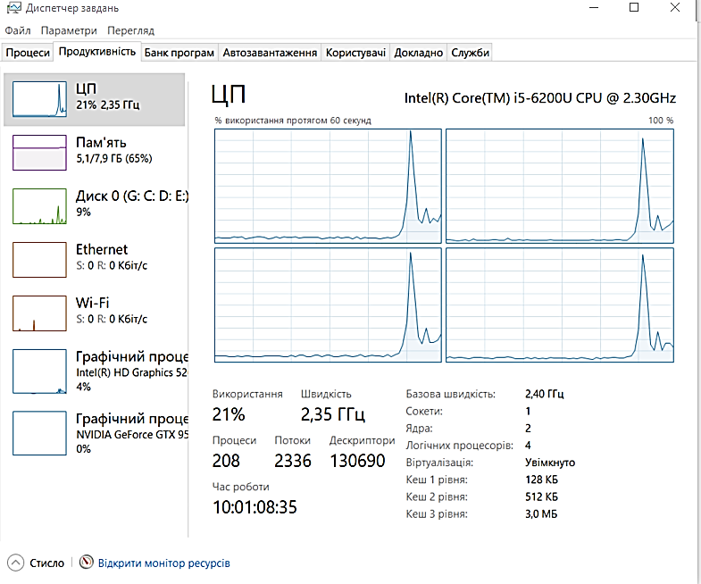Lab 5 start

Task 1 start

Task 1 end

Task 2 start

Task 2 end

Task 3 start

Task 3 end

Lab 5 end

Press Enter...

